Aspirin Synthesis Condition Optimization Lab

Introduction
- Aspirin can be synthesized by esterification reaction between salicylic acid (also known as o-hydroxybenzoic acid or 2-hydroxybenzoic acid) and acetic anhydride. Acetic anhydride is a lachrymator. So, this reaction is to be performed in a chemical hood. In this reaction, acetic anhydride is the excess reagent. The % yield is to be calculated based on the amount of the salicylic acid used.
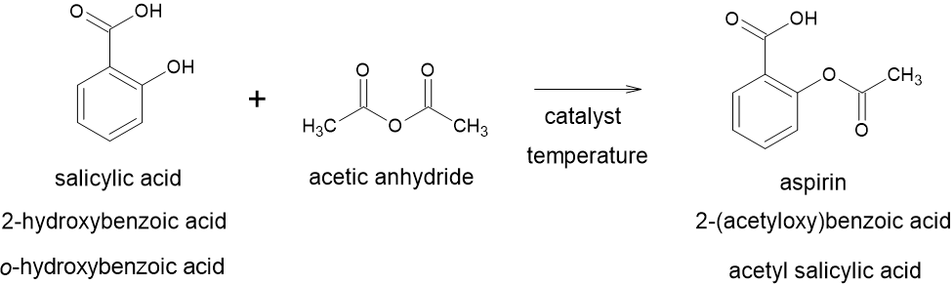
Scheme 1: Aspirin Synthesis Reaction

- The choices for catalysts are conc. H₂SO₄ (sulfuric acid) or 85% H₃PO₄ (syrupy phosphoric acid).
- The choices for temperatures are room temperature or elevated temperature (75 ^{O}C). The reverse reaction for the synthesis is hydrolysis and/or decomposition of the aspirin. Much higher elevated temperatures tend to accelerate those unwanted reactions; thereby, decreasing the yield of the desired product. As direct heating is less controlled, a hot water bath will be used. Care should be taken such that it DOES NOT turn into a steam bath.
- Salicylic acid due to the phenolic OH— group develops a violet color with FeCl₃ solution. Aspirin does not give a positive test, i.e, it does not develop a violet color with FeCl₃ solution.
- In this experiment, we will perform 8 different scenarios to ascertain which combination of the catalyst, temperature and the quenching method gives us the best yield. Following the isolation of the crude product by filtration, we will measure the melting point, perform TLC and FeCl₃ test to determine the purity.
- We may have to recrystallize the product. All the aforementioned tests will be performed on the recrystallized product as well.
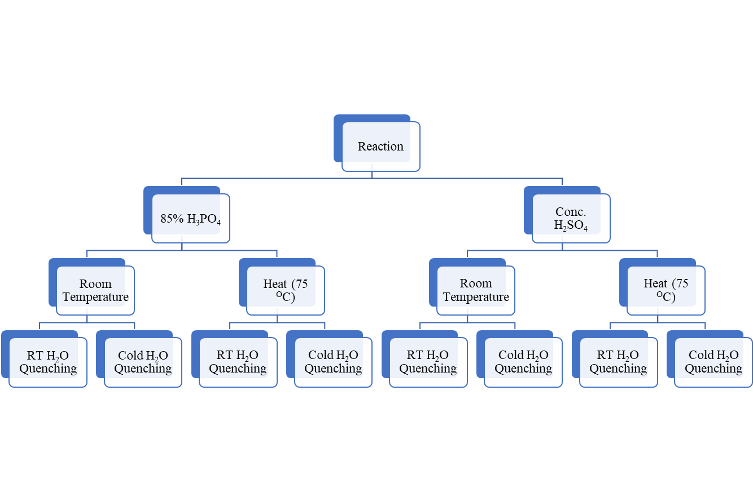
Figure 1: 8 Scenarios of the Experiment

General Lab Safety Rules
- Treat all chemicals as toxic
- Ask your instructor whenever you have questions
- No food, no drink, no smoke
- Clothes cover shoulder, shoes cover toes
- Long hair must be tied up
- Clean up glassware and work surface after lab
- Wash hands before you leave
- SDS Information: Salicylic Acid (SDS 204), Acetic anhydride (SDS 004), Hexanes (SDS 073), Ethyl acetate (SDS 061), Acetic acid (SDS 002), Phosphoric acid (SDS 124), Ethanol (SDS 064), Aspirin (SDS 008)

Experimental

Water Bath Set-Up
- Place an about ⅔ filled 400 mL beaker (~250 mL mark) with tap water on a hotplate set at point 7 on the heat regulator. Dip the thermometer from time to time to check the temperature.
- The temperature must not go beyond 75 °C. Monitor the temperature throughout the lab period as you will need this for recrystallization step as well.
- Check with your instructor if you need to set this up or not.

Ice Bath Set-Up
- Place an about ⅓ filled 400 mL beaker (~250 mL mark) with tap water. Add ice to it so that it is only ⅔ filled. Dip the thermometer from time to time to check the temperature.
- The temperature should be between 5 °C – 15 °C.
- Everyone needs to set up their own ice bath.

Reaction I: 85% H₃PO₄, Room Temperature Reaction & Room Temperature Water Quenching
- Weigh ~2.5 g salicylic acid in a 125 mL Erlenmeyer flask. Record the exact mass shown on the balance. Add a small stirrer to the flask in a way so that the flask does not break. Take the entire ensemble inside a chemical hood. From now on unless and otherwise specified, all the steps MUST be performed under the chemical hood.
- Add 5 mL of acetic anhydride to the salicylic acid and swirl.
- Add 5 drops of 85% H₃PO₄ and swirl.
- Set it to stir on a moderate speed (use your judgement) on a stir-plate for 15 minutes.
- After 15 minutes, stop the stirring. Slowly add 15 mL of DI H₂O while swirling the flask.
- Place the Erlenmeyer flask in the previously made ice bath for 15 minutes. If within the first 3 minutes, you do not see any precipitate, scratch the walls with a glass rod.
- After 15 minutes, filter the solid. Wash with 3 mL ice cold DI H₂O. Dry under vacuum, if possible.
- Check the melting point, and FeCl₃ test results of the crude product.
- Save aside a little bit of the crude product in a test-tube. Label it.
- Recrystallize the crude product in 3 mL ethanol in a 50 mL beaker if your TLC and FeCl₃ test results show presence of salicylic acid.
- Check the melting point, and FeCl₃ test results of the recrystallized product.
- Save aside a little bit of the recrystallized product in a test-tube. Label it.

Reaction II: 85% H₃PO₄, Room Temperature Reaction & Cold Water Quenching
- Weigh ~2.5 g salicylic acid in a 125 mL Erlenmeyer flask. Record the exact mass shown on the balance. Add a small stirrer to the flask in a way so that the flask does not break. Take the entire ensemble inside a chemical hood. From now on unless and otherwise specified, all the steps MUST be performed under the chemical hood.
- Add 3 mL of acetic anhydride to the salicylic acid and swirl.
- Add 5 drops of 85% H₃PO₄ and swirl.
- Set it to stir on a moderate speed (use your judgement) on a stir-plate for 15 minutes.
- After 15 minutes, stop the stirring and remove the flask from the water bath. Slowly add ice cold 15 mL of DI H₂O while swirling the flask.
- Place the Erlenmeyer flask in the previously made ice bath for 15 minutes. If within the first 3 minutes, you do not see any precipitate, scratch the walls with a glass rod.
- After 15 minutes, filter the solid. Wash with 3 mL ice cold DI H₂O. Dry under vacuum, if possible.
- Check the melting point, and FeCl₃ test results of the crude product.
- Save aside a little bit of the crude product in a test-tube. Label it.
- Recrystallize the crude product in 3 mL ethanol in a 50 mL beaker if your TLC and FeCl₃ test results show presence of salicylic acid.
- Check the melting point, and FeCl₃ test results of the recrystallized product.
- Save aside a little bit of the recrystallized product in a test-tube. Label it.

Reaction III: 85% H₃PO₄, 75 °C Temperature Reaction & Room Temperature Water Quenching
- Weigh ~2.5 g salicylic acid in a 125 mL Erlenmeyer flask. Record the exact mass shown on the balance. Add a small stirrer to the flask in a way so that the flask does not break. Take the entire ensemble inside a chemical hood. From now on unless and otherwise specified, all the steps MUST be performed under the chemical hood.
- Add 3 mL of acetic anhydride to the salicylic acid and swirl. Do this under the chemical hood.
- Add 5 drops of 85% H₃PO₄ and swirl.
- Set it to stir on a moderate speed (use your judgement) on a stir-plate in a hot water bath for 15 minutes.
- After 15 minutes, stop the stirring and remove the flask from the water bath. Slowly add 15 mL of DI H₂O while swirling the flask.
- Place the Erlenmeyer flask in the previously made ice bath for 15 minutes. If within the first 3 minutes, you do not see any precipitate, scratch the walls with a glass rod.
- After 15 minutes, filter the solid. Wash with 3 mL ice cold DI H₂O. Dry under vacuum, if possible.
- Check the melting point, and FeCl₃ test results of the crude product.
- Save aside a little bit of the crude product in a test-tube. Label it.
- Recrystallize the crude product in 3 mL ethanol in a 50 mL beaker if your TLC and FeCl₃ test results show presence of salicylic acid.
- Check the melting point, TLC (50/50 Hexanes/Ethyl Acetate) and FeCl₃ test results of the recrystallized product.
- Save aside a little bit of the recrystallized product in a test-tube. Label it.

Reaction IV: 85% H₃PO₄, 75 °C Temperature Reaction & Cold Water Quenching
- Weigh ~2.5 g salicylic acid in a 125 mL Erlenmeyer flask. Record the exact mass shown on the balance. Add a small stirrer to the flask in a way so that the flask does not break. Take the entire ensemble inside a chemical hood. From now on unless and otherwise specified, all the steps MUST be performed under the chemical hood.
- Add 3 mL of acetic anhydride to the salicylic acid and swirl.
- Add 5 drops of 85% H₃PO₄ and swirl.
- Set it to stir on a moderate speed (use your judgement) on a stir-plate in a hot water bath for 15 minutes.
- After 15 minutes, stop the stirring and remove the flask from the water bath. Slowly add ice cold 15 mL of DI H₂O while swirling the flask.
- Place the Erlenmeyer flask in the previously made ice bath for 15 minutes. If within the first 3 minutes, you do not see any precipitate, scratch the walls with a glass rod.
- After 15 minutes, filter the solid. Wash with 3 mL ice cold DI H₂O. Dry under vacuum, if possible.
- Check the melting point, and FeCl₃ test results of the crude product.
- Save aside a little bit of the crude product in a test-tube. Label it.
- Recrystallize the crude product in 3 mL ethanol in a 50 mL beaker if your TLC and FeCl₃ test results show presence of salicylic acid.
- Check the melting point, and FeCl₃ test results of the recrystallized product.
- Save aside a little bit of the recrystallized product in a test-tube. Label it.

Reaction V: Conc. H₂SO₄, Room Temperature Reaction & Room Temperature Water Quenching
- Weigh ~2.5 g salicylic acid in a 125 mL Erlenmeyer flask. Record the exact mass shown on the balance. Add a small stirrer to the flask in a way so that the flask does not break. Take the entire ensemble inside a chemical hood. From now on unless and otherwise specified, all the steps MUST be performed under the chemical hood.
- Add 3 mL of acetic anhydride to the salicylic acid and swirl.
- Add 5 drops of Conc. H₂SO₄ and swirl.
- Set it to stir on a moderate speed (use your judgement) on a stir-plate for 15 minutes.
- After 15 minutes, stop the stirring and remove the flask from the water bath. Slowly add 15 mL of DI H₂O while swirling the flask.
- Place the Erlenmeyer flask in the previously made ice bath for 15 minutes. If within the first 3 minutes, you do not see any precipitate, scratch the walls with a glass rod.
- After 15 minutes, filter the solid. Wash with 3 mL ice cold DI H₂O. Dry under vacuum, if possible.
- Check the melting point, and FeCl₃ test results of the crude product.
- Save aside a little bit of the crude product in a test-tube. Label it.
- Recrystallize the crude product in 3 mL ethanol in a 50 mL beaker if your TLC and FeCl₃ test results show presence of salicylic acid.
- Check the melting point, and FeCl₃ test results of the recrystallized product.
- Save aside a little bit of the recrystallized product in a test-tube. Label it.

Reaction VI: Conc. H₂SO₄, 75 °C Temperature Reaction & Room Temperature Water Quenching
- Weigh ~2.5 g salicylic acid in a 125 mL Erlenmeyer flask. Record the exact mass shown on the balance. Add a small stirrer to the flask in a way so that the flask does not break. Take the entire ensemble inside a chemical hood. From now on unless and otherwise specified, all the steps MUST be performed under the chemical hood.
- Add 3 mL of acetic anhydride to the salicylic acid and swirl.
- Add 5 drops of Conc. H₂SO₄ and swirl.
- Set it to stir on a moderate speed (use your judgement) on a stir-plate in a hot water bath for 15 minutes.
- After 15 minutes, stop the stirring and remove the flask from the water bath. Slowly add 15 mL of DI H₂O while swirling the flask.
- Place the Erlenmeyer flask in the previously made ice bath for 15 minutes. If within the first 3 minutes, you do not see any precipitate, scratch the walls with a glass rod.
- After 15 minutes, filter the solid. Wash with 3 mL ice cold DI H₂O. Dry under vacuum, if possible.
- Check the melting point, and FeCl₃ test results of the crude product.
- Save aside a little bit of the crude product in a test-tube. Label it.
- Recrystallize the crude product in 3 mL ethanol in a 50 mL beaker if your TLC and FeCl₃ test results show presence of salicylic acid.
- Check the melting point, and FeCl₃ test results of the recrystallized product.
- Save aside a little bit of the recrystallized product in a test-tube. Label it.

Reaction VII: Conc. H₂SO₄, Room Temperature Reaction & Cold Water Quenching
- Weigh ~2.5 g salicylic acid in a 125 mL Erlenmeyer flask. Record the exact mass shown on the balance. Add a small stirrer to the flask in a way so that the flask does not break. Take the entire ensemble inside a chemical hood. From now on unless and otherwise specified, all the steps MUST be performed under the chemical hood.
- Add 3 mL of acetic anhydride to the salicylic acid and swirl.
- Add 5 drops of Conc. H₂SO₄ and swirl.
- Set it to stir on a moderate speed (use your judgement) on a stir-plate for 15 minutes.
- After 15 minutes, stop the stirring and remove the flask from the water bath. Slowly add ice cold 15 mL of DI H₂O while swirling the flask.
- Place the Erlenmeyer flask in the previously made ice bath for 15 minutes. If within the first 3 minutes, you do not see any precipitate, scratch the walls with a glass rod.
- After 15 minutes, filter the solid. Wash with 3 mL ice cold DI H₂O. Dry under vacuum, if possible.
- Check the melting point, and FeCl₃ test results of the crude product.
- Save aside a little bit of the crude product in a test-tube. Label it.
- Recrystallize the crude product in 3 mL ethanol in a 50 mL beaker if your TLC and FeCl₃ test results show presence of salicylic acid.
- Check the melting point, and FeCl₃ test results of the recrystallized product.
- Save aside a little bit of the recrystallized product in a test-tube. Label it.

Reaction VIII: Conc. H₂SO₄, 75 °C Temperature Reaction & Cold Water Quenching
- Weigh ~2.5 g salicylic acid in a 125 mL Erlenmeyer flask. Record the exact mass shown on the balance. Add a small stirrer to the flask in a way so that the flask does not break. Take the entire ensemble inside a chemical hood. From now on unless and otherwise specified, all the steps MUST be performed under the chemical hood.
- Add 3 mL of acetic anhydride to the salicylic acid and swirl.
- Add 5 drops of Conc. H₂SO₄ and swirl.
- Set it to stir on a moderate speed (use your judgement) on a stir-plate in a hot water bath for 15 minutes.
- After 15 minutes, stop the stirring and remove the flask from the water bath. Slowly add ice cold 15 mL of DI H₂O while swirling the flask.
- Place the Erlenmeyer flask in the previously made ice bath for 15 minutes. If within the first 3 minutes, you do not see any precipitate, scratch the walls with a glass rod.
- After 15 minutes, filter the solid. Wash with 3 mL ice cold DI H₂O. Dry under vacuum, if possible.
- Check the melting point, and FeCl₃ test results of the crude product.
- Save aside a little bit of the crude product in a test-tube. Label it.
- Recrystallize the crude product in 3 mL ethanol in a 50 mL beaker if your TLC and FeCl₃ test results show presence of salicylic acid.
- Check the melting point, and FeCl₃ test results of the recrystallized product.
- Save aside a little bit of the recrystallized product in a test-tube. Label it.

TLC of the Compounds
- At this point, you should have 8 test-tubes containing crude products & another 8 test-tubes containing recrystallized products.
- For each pair of the crude and the recrystallized products, run a TLC in 50/50 Hexane/Ethyl Acetate with the starting product. It means that there should be 3 spots – 1 for the salicylic acid (starting material – left spot), crude product (preferably the middle spot), and the recrystallized product (the right spot).
- Take a picture of the TLC plate. Place them in the proper places in this report. Re-size them to fit nicely in the designated spaces. DO NOT make the formatting go off.

Results & Discussion

Table 1: % Yield Data
Reaction # | Salicylic Acid Mass (g) | Crude Aspirin Mass (g) | Recrystallized Aspirin Mass (g) | Crude Aspirin Yield (%) | Recrystallized Aspirin Yield (%)
I
II
III
IV
V
VI
VII
VIII

Table 2: TLC Data for R_{f} Values
Reaction # | Salicylic Acid |  | Crude Aspirin |  | Recrystallized Aspirin
 | # Spots | R_{f} Values | # Spots | R_{f} Values | # Spots | R_{f} Values
I
II
III
IV
V
VI
VII
VIII

Table 3: Melting Point & FeCl₃ Test Data
Reaction # | Crude Aspirin |  | Recrystallized Aspirin
 | Melting Point (°C) | FeCl₃ Test | Melting Point (°C) | FeCl₃ Test
I
II
III
IV
V
VI
VII
VIII

Figure 2A: TLC of Reaction I | Figure 2B: TLC of Reaction II

Figure 2C: TLC of Reaction III | Figure 2D: TLC of Reaction IV

Figure 2E: TLC of Reaction V | Figure 2F: TLC of Reaction VI

Figure 2G: TLC of Reaction VII | Figure 2H: TLC of Reaction VIII

Conclusions
- Based on your % yield data, which condition is the most optimum for the synthesis of aspirin? Explain in a sentence or two.
- On a scale of 1 to 5 (1 – none at all & 5 – the highest), rate your confidence in performing a melting point analysis. Explain in a sentence or two.
- On a scale of 1 to 5 (1 – none at all & 5 – the highest), rate your confidence in performing a TLC analysis (including eluant preparation, loading the sample on the plate, figuring out the R_{f} values). Explain in about 5 sentences.

